Timeline

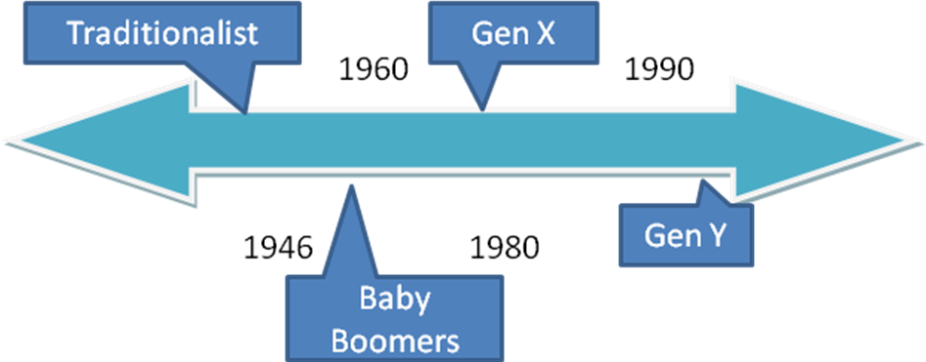

Notes
________________________________________________________________________________________________________________________________________________________________________________________________________________________________________________________________________________________________________________________________________________________________________________________________________________________________________________________________________________________________________________________________________________________________________________________________________________________________________________

