Worksheet: Identifying Participants’ Needs
As you prepared for training today, what was going through your mind? Were you curious about what you could learn? Excited about meeting new people? Frustrated that a day of training is taking you away from other work? A combination of things?
Everyone comes to training with their own background experiences and knowledge, and their own motivation. This worksheet is to help you rate yours.
How would you rate your own level of knowledge about training?

Awareness means that you have some knowledge of what training is like that you have gained through your work experience. You have probably attended training in the past, but have not conducted training yet.
Familiarity means that you have some information about working as a trainer, and you know some of the basic principles of being a trainer.
Competence means that you can apply the knowledge you have, and already have some skill in training. You have conducted at least three training sessions.
Mastery means that you have a lot of experience as a trainer, and are ready to teach other people how to train.

Next, rate your motivation factor.
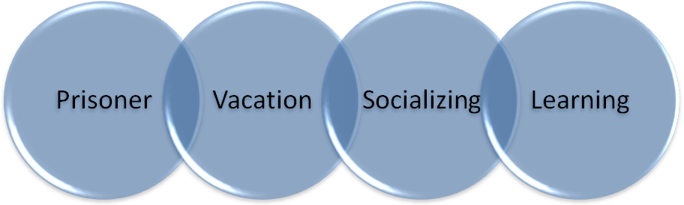
A Prisoner is someone who is forced (probably by their boss) to be here today, but has little to no interest in the subject matter and is not happy to be a part of this class.
A Vacationer is looking forward to a day away from their desk and the pressures of everyday work.
A Socializer is looking forward to having some fun, meeting new people, and networking.
The Learner is here ready to gain new skills and knowledge.

