Handout: Nominal Group Technique
Provide the question and ask team members to generate ideas individually and silently for about five to ten minutes.
Use a round robin, asking each participant to present one idea at a time from his or her list. Record the ideas on a flip chart
Ask the group to discuss the ideas, providing clarification, support, or nonsupport for the posted ideas . Hitchhiking (coming up with a new idea based on when you heard) is encouraged.
Instruct each group member to vote, using ranking or rating.
When rating the ideas, each participant distributes a set number of points (e.g., 100) across the ideas.
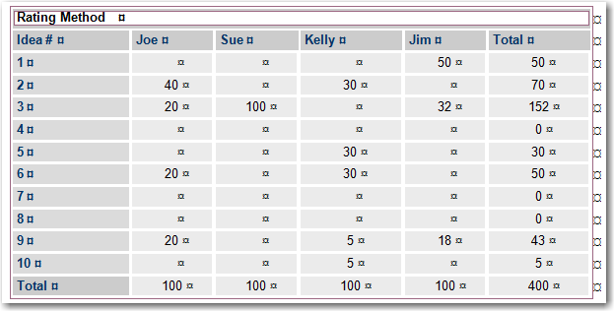
For ranking, each participant is asked to choose roughly half of the total number of ideas generated, and to rank these from most important to least important. This process will place emphasis on fewer ideas.
In preparation for recording the vote, the leader should list the number of each idea on a separate piece of paper. When the actual votes are recorded, he or she will record the rank assigned by each participant to the idea, as seen in the example below.
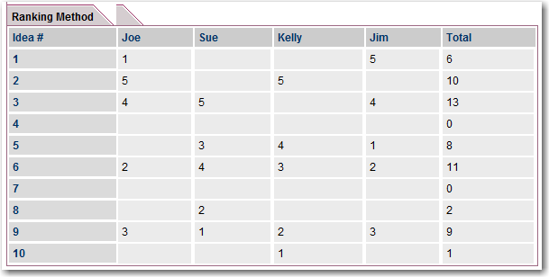
In this final step, individual judgments on the ideas are combined into a group decision. Final tallying can be either by the rating or ranking method.
If there are any inconsistent voting patterns or items with too few or too many votes, the group discusses them in may opt to discard them.
The final vote helps to: which one
Records the final group judgment in relation the initial question
Advantages of the nominal group technique:
- It generates a greater number of ideas than traditional group discussions.
- Balances the influence of individuals by limiting the power of opinion makers
- Diminishes competition and pressure to conform, based on status within the group.
- Encourages participants to confront issues through constructive problem solving.
- You keep them on your desktop Allows the group to prioritize ideas democratically.
- Typically provides a greater sense of closure than can be obtained through group discussion.
Disadvantages of the nominal group technique
•It requires preparation.
• It is regimented and lends itself only to a single purpose, single-topic meeting.
• Discussion is minimized, and thus does not allow for the full development of ideas, and therefore can be a less stimulating group process than other techniques.

