Handout Four: Capital Statement

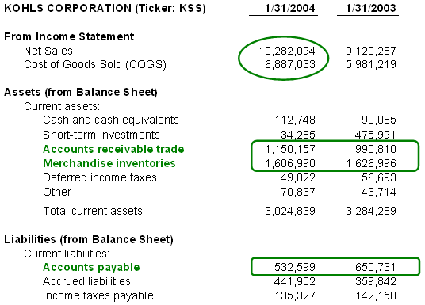
investopedia.com

