Handout Six: Trial Balance

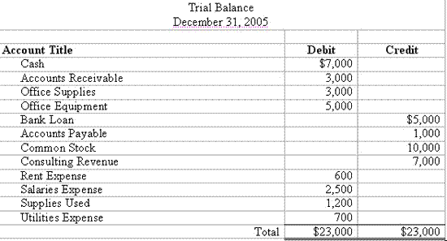
Moneyinstructor.com

