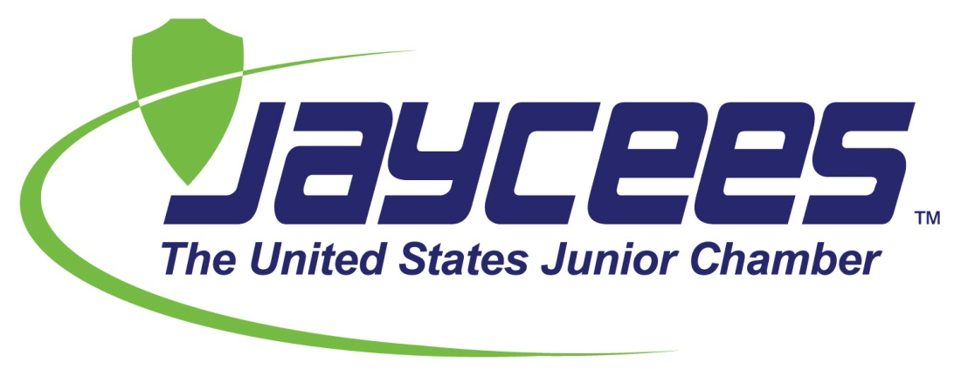

The Junior Chamber Youth program, under the United States Jaycees, is a program aimed toward today’s children. It is an extension of the mission, goals and objectives of the US Jaycees for our youth to gain leadership skills within the community. These skills are gained through volunteering for community service projects, interacting with others and leading activities during regular meetings.

Starting a Junior Chamber Chapter in Middle Schools/High Schools

Welcome to the future of the Jaycees! Junior Chamber is for youth between the ages of 14 and 17 and is modeled after the Junior Chamber (Jaycees) organization. This new program is one of the most important projects to the National Jaycees. Junior Chamber Youth Chapters shows youth what the Jaycee movement is all about.
To insure that we have great leaders in the future, we must help guide and cultivate our youth today. A Junior Chamber Youth chapter is intended to teach our youth the necessary leadership, community involvement, and self-confidence that every young person needs to succeed in our world today and become an active citizen. We will continue to work on a program guide that will give you every resource to charter a Junior Chamber Youth chapter in your area or town. Congratulations on being part of the FUTURE OF THE JAYCEES!

Why you should start a Junior Chamber Youth Chapter
· Active Citizenship for the Youth
· Building Future Jaycee members
· Leadership Training for members
· Develop Community Awareness for youth
· Nurture Self-Confidence
· Create fun and constructive events for youth

How do I start a Junior Chamber Youth Chapter?
· Appoint someone to be the Junior Chamber Chapter Advisor
· Form a recruiting team
· Create a plan of action
· Organize a Junior Chamber Membership Event
· Charter Junior Chamber Youth chapter and elect youth officers
· Set monthly meeting dates and times
· Complete charter information forms

Junior Chamber Youth Creed
We believe:
That work done for the benefit of others is its own reward;
That responsibility is the first step in becoming an adult;
That belonging to a community is a privilege, not a right;
That earth’s great treasure lies in human personality;
And that service to humanity is the best work of life!

Code of Conduct
As a Junior Chamber Member please remember that your behavior is representing your high school and your community. You should be responsible and treat others with respect at all times. Please understand that while participating in Junior Chamber events swearing, name calling, bullying, destruction of property, smoking, drinking, or any other activities deemed inappropriate by the Junior Chamber officers or advisors will not be tolerated and disciplinary action may be taken by your school.

Selling Points of a Junior Chamber Youth Chapter
Community Improvement – This is what the youth can do for the community, as in their school community and the community as a whole. Prospective members must know that together they can have an impact on their community, and that one goal of a Junior Chamber Youth chapter is community development and active citizenship.

Individual Growth – You can describe to your potential Junior Chamber Youth member how they can expand and improve their self-confidence and leadership skills in order to succeed in life. Tell the prospect about the various opportunities in Individual Development courses designed to further self-growth.

Group Involvement – By belonging to a group like the Junior Chamber, it can give youth togetherness with other youth. The youth are looking for a way to have involvement and belong. This also gives them a way to experience the Jaycee movement in hopes of being a Junior Chamber (Jaycee) member in the future.

