Project Management Guide (PMG)

Chapter Name: Peninsula State Name: Virginia
Project Name: Girl’s STEM Camp
Area of Opportunity: Choose an item.
Category: Choose an item.
Project Manager’s Officer: Click here to enter text. Primary Phone: Click here to enter text.
Email Address: Click here to enter text.
Supervising Chapter Officer: Click here to enter text. Primary Phone: Click here to enter text.
Email Address: Click here to enter text.

PURPOSE OF THE GUIDE:
Good advanced planning and record-keeping will assure success. Use this guide in planning and conducting the project by answering each of the following questions and updating information as the project progresses. Evaluate the impact of your project and provide recommendations for future Project Managers.

PLANNING
- Primary Purpose (How does this project align with the Jaycee Mission Statement, which is to provide development opportunities for young people to create positive change?)
The girl’s STEM camp focuses on promoting interest and engagement for middle school girls in the Science, Technology, Engineering, and Mathematics fields through hands-on activities.

- Project Overview
  - Give a brief description of the proposed project and background information. (Who, what, when, where and why?)
Research has shown that the middle school to early high school range is where most girls lose interest in or are discourage from STEM fields and activities. The camp is held at a local community center over the summer, which allows for engaging the girls without added school pressure.

  - How will this project benefit the individual member, the chapter, and the community?
By utilizing chapter members as instructors, the STEM camp project allows them to interact with the youth of the community, while creating a good public image and connections for the Chapter, and encouraging the development of the girls into young leaders who can support change in their community.

  - List specific and measurable goals to be accomplished by this project. (Example: Involve 25 Jaycees. Recruit 2 new members.)
    - Goal 1 – Have 3 Chapter members lead activities.
    - Goal 2 – Have at least 40 girls attend.
    - Goal 3 – Involve at least 12 chapter members
    - Goal 4 – Partner with at least 1 community group

- Steps to implementation: List the specific steps to bring this project to a successful completion, showing the planned dates for each step, and the person or people responsible for each step.

TASK/ACTIVITY | START DATE | FINISH DATE | % COMPLETE | PERSON(S) RESPONSIBLE | CRITICAL TASK (Y/N) | FOR CRITICAL TASKS:
 |  |  |  |  |  | POTENTIAL PROBLEM | POTENTIAL SOLUTION
Identify and Secure Location | 2/16 | 4/7 | 100% | Taylor | Y | None of preferred locations are available | Search Alternative Options
Identify Projects for Rotation | 4/12 | 4/23 | 100% | All | Y | Cannot find enough project leaders | Appeal to chapter at large
Gift Card Requests | 4/12 | 6/8 | 100% | All | N | - | -
Set up Registration | 4/23 | 5/8 | 100% | Alex | Y | Issues with Eventbrite | Consider a different event website
Design Poster/Flyer | 4/12 | 5/2 | 100% | Suzanne | N | - | -
Distribute Information to the Community | 5/4 | 6/10 | 100% | All | Y | Cannot get flyer distributed to schools | Distribute more widely to community centers, etc.
Close Registration | 6/8 | 6/18 | 100% | - | N | - | -
Secure necessary Materials | 6/12 | 6/17 | 100% | Alex, Taylor, Suzanne | Y | Unable to acquire materials for one of the projects | Have a back-up project planned
Secure Snack | 6/15 | 6/15 | 100% | Suzanne | N | - | -

- Critical Contacts
Project Manager
Name: Taylor Chamberlain
Email:
Phone:
Duties: Schedule and lead committee meetings, secure location, organize material acquiring efforts, lead an activity, distribute gift card request letters, acquire materials for self led activity, disseminat project information to the community
President
Name: Suzanne Midgely
Email:
Phone:
Duties: Lead an activity, acquire food and beverages, design flyer and ensure information is loaded to Peninsula Jaycees website, distribute gift card request letters, acquire materials for self-led activity, disseminate project information to the community

Public Relations and Material Requests
Name: Beverly Williams
Email:
Phone:
Duties: Write gift card request letters, distribute gift card request letters, assist in identifying key community resources, disseminate project information to the community

Public Relations and Registration
Name: Alexandra Snyder
Email:
Phone:
Duties: Set up registration, lead an activity, distribute gift card request letters, acquire materials for self-led activities, disseminate project information to the community

Community Contacts and Insight
Name: Angela Benjamin
Email:
Phone:
Duties: Identify key community resources, distribute gift card request letters, disseminate project information to the community

- What specific materials, supplies, and resources will be required?

Material or Supply & Quantity | Person Responsible for Obtaining | Date Needed | Donated, Owned or Purchased? | Cost/Value
Activity Materials (e.g. popsicle sticks, glue, baking soda, etc.) | Alex, Taylor, Suzanne | 6/17 | Purchased | ~ $200
Food for Snacks | Suzanne | 6/17 | Purchased | ~$250
Registration Table and Materials | Taylor | 6/18 | Owned (Location’s) | $0
Flyer Printing | Alex/Suzanne | 6/1 | Purchased | $100

- Complete a proposed budget indicating all anticipated income and expenses

Proposed Budget
INCOME: PROPOSED
Appropriation from chapter $
Value of donated items (list)
List donated items and assign a value. $
List donated items and assign a value. $
List donated items and assign a value. $
List donated items and assign a value. $
Other sources of income (list)
$5 Registration Fee (50 students) $200.00
List potential income (raffles, fundraisers, etc.) $
List potential income (raffles, fundraisers, etc.) $
List potential income (raffles, fundraisers, etc.) $
List potential income (raffles, fundraisers, etc.) $
List potential income (raffles, fundraisers, etc.) $
__________________________________________
TOTAL INCOME $200.00

EXPENSES: PROPOSED
Value of donated items (list)
List donated items and assign a value. $
List donated items and assign a value. $
List donated items and assign a value. $
List donated items and assign a value. $
Other expenses (list)
Activity Materials (e.g. Popsicle sticks, Glue, Baking Soda) $200.00
Lunch (50 students & 15 adults) $300.00
List potential expenses (i.e.: materials for the project). $
List potential expenses (i.e.: materials for the project). $
List potential expenses (i.e.: materials for the project). $
List potential expenses (i.e.: materials for the project). $

Return of appropriation from chapter $
Return to chapter (profit) $
(OR Donation to Insert donation recipient's name)
__________________________________________
TOTAL EXPENSES $500.00

- Describe the potential problems and solutions to successfully complete this project.

Potential Problem: Not enough registrants
Potential Solution: Push information to wider parts of the area, different community centers, and schools/after school programs. If necessary push registration to chapter/friends of the chapter’s children.

Potential Problem: Not enough volunteers
Potential Solution: Reach out to other Chapters, community groups/programs who may have leaders who would be interested in assisting.

Potential Problem: Non-ideal location/time-frame
Potential Solution: Adapt the project plan so as to best utilize the available resources.

EVALUATION

- List solutions and/or recommendations for future Project Managers. (List here anything that you would do differently the next time this project is run. Would you make contacts earlier? Was manpower sufficient? Could this project be broadened or should it be more focused?)

- Begin efforts to distribute information through school system sooner. Because the schools require the flyer to be approved by the school board and that the flyers for distribution be provided by the organization, this is a time consuming process that eats into the budget with printing fees.
- Have one activity more than the intended number of student groups (i.e. four projects for three groups of students). This allows for activity leads and assistants to take breaks and potentially participate in or observe the other activities. It also facilitates a smoother transition process from one activity to another.
- Lysol or similar cleaning wipes for cleaning up during and after.
- Bigger or multiple rooms to conduct activities.
- Full day project would be better to facilitate medium or larger groups.
- Push harder to get community group (Girl Scouts, Girls Inc., etc.) involvement/support.

- Results

Primary Purpose: The girl’s STEM camp focuses on promoting interest and engagement for middle school girls in the Science, Technology, Engineering, and Mathematics fields through hands-on activities.

Results: The girl’s STEM camp provided three engaging activities for students to participate in, one each in the fields of Science, Physics, and Electrical Engineer. In addition, a presentation by the Menchville Robotics team offered a Technology facet to the program.

Goal 1: Have 3 Chapter members lead activities.
Result: 3 members lead activities. 100% success.

Goal 2: Have at least 40 girls attend
Result: 12 students attended the event. 30% success.

Goal 3: Involve at least 12 chapter members
Result: Including members who assisted with planning and community contacts, 11 members were involved. 92% success

Goal 4: Partner with at least 1 community group
Result: Midtown Community Center provided the space free for the first three hours. A contact with the Girl Scouts disseminated information and led to several girls’ enrollment. 100% success.

Project Summary:

The Girl’s STEM Camp project began as a passion project and ended a success, if a smaller one than anticipated. The intent was to garner increased attention and support for young girls to pursue career paths in STEM so that they might later be able to create change in their community. Every girl was engaged and enthusiastic at some point during the course of the project. They asked questions about other aspects of the projects, and tried different approaches without prompting when the activity didn’t appear to be going the way it was intended. Growth, on both an intellectual learning level and a teamwork skills level was evident in both the girls and the volunteers. Over the course of the day, volunteers became involved with drawing out the interests of the girls and encouraging them to pursue them, or to be open to new possibilities if they were unsure. The girls began to help each other and make suggestions for corrections, though they kept a certain level of friendly competition active amongst them.

Although the project did not meet it’s attendance goals, the more personal atmosphere created by the situation may have lead to increased enthusiasm since volunteers were able to have direct conversations with each girl and to offer advice without being distracted.

Project Benefits:

Individual Impact: For individual members, this project offered the opportunity to learn with the girls and to share their enthusiasm for the activities. The activity leaders gained development by learning about their activity and determining how best to present it in a fun and entertaining way for the girls. As a project leader, this project opportunity to step outside my normal comfort zone and experience what project planning and management is about. I learned several things about scheduling and creating contacts that will be helpful to me in my everyday life. As a STEM enthusiast, this project was an excellent and enjoyable opportunity to share my love of STEM with the girls and to encourage them to see a potential future career or hobby in STEM.

Chapter Impact: This project provided an increased public awareness for the chapter and created a strong contact at Brittingham – Midtown Community Center for the Chapter.

Community Impact: Community impact for this project centered on creating an opportunity for young girl’s to see relatable and interesting possibilities for future career paths in STEM.

- Appendices (Attach your final financial statement and list of contacts. *Optional: Attach other documentation as appropriate)
  - Final Financial Statement
  - Contacts
  - Contracts
  - Pictures
  - Press Release
  - Flyer
  - School Board Approval Letter

Appendix A
Final Financial Statement

INCOME: PROPOSED ACTUAL
Appropriation from chapter $0 $0
Value of donated items (list)
Lowe’s Gift Card $20 $20
Food Lion Gift Card $20 $20
Farm Fresh Gift Card $20 $25
Costco Gift Card $20 $25
Other sources of income (list)
None $0 $0
__________________________________________
TOTAL INCOME $80 $90

EXPENSES: PROPOSED ACTUAL
Value of donated items (list)
Light bulb activity (goggles, wire, etc.) $40 $0
List donated items and assign a value. $ $
List donated items and assign a value. $ $
List donated items and assign a value. $ $
Other expenses (list)
Bouncy Ball Activity Materials $83 $30
Catapult Activity Materials $40 $10
Light bulb Activity Materials $63 $30
Printing $100 $20
Snacks/Water $30 $0
Room Rental $53 $53

Return of appropriation from chapter $0 $0
Return to chapter (profit) $0 $0
(OR Donation to Insert donation recipient's name)
__________________________________________
TOTAL EXPENSES $409 $143
Appendix B
Contacts
Location: Brittingham-Midtown Community Center
Name: Jason Brown
Phone Number:
E-mail:

Location: Hampton School Board
Name: Ann Bane
Phone Number:
E-mail:

Appendix C
Contracts and Agreements
Appendix D
Pictures
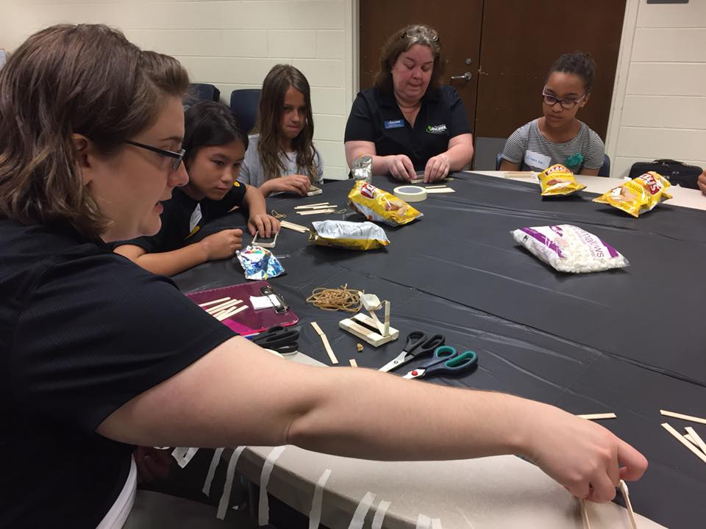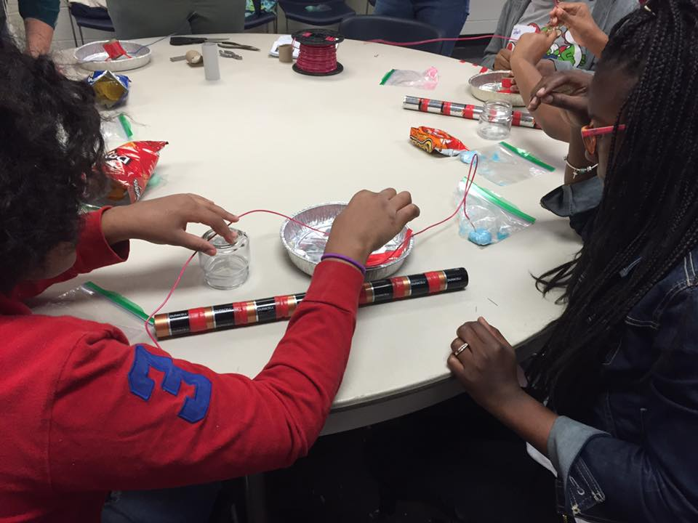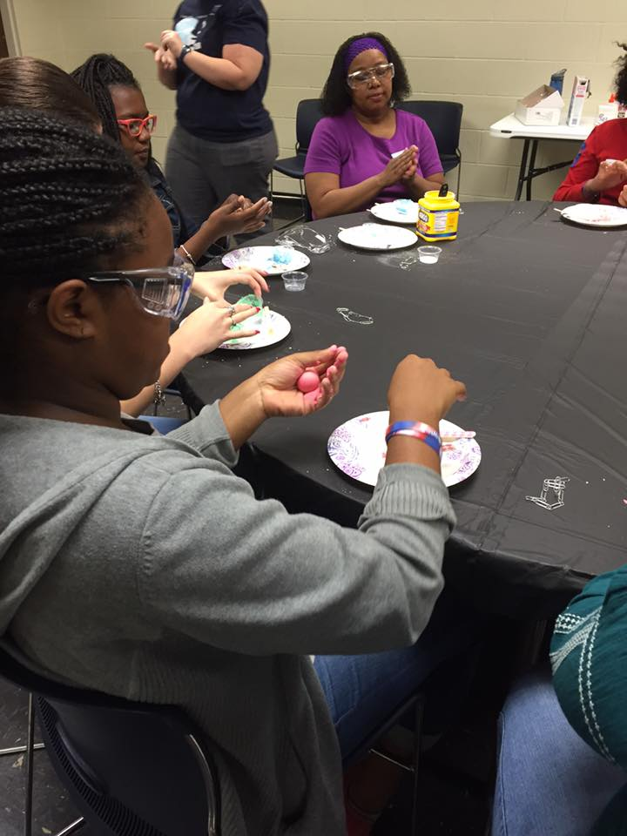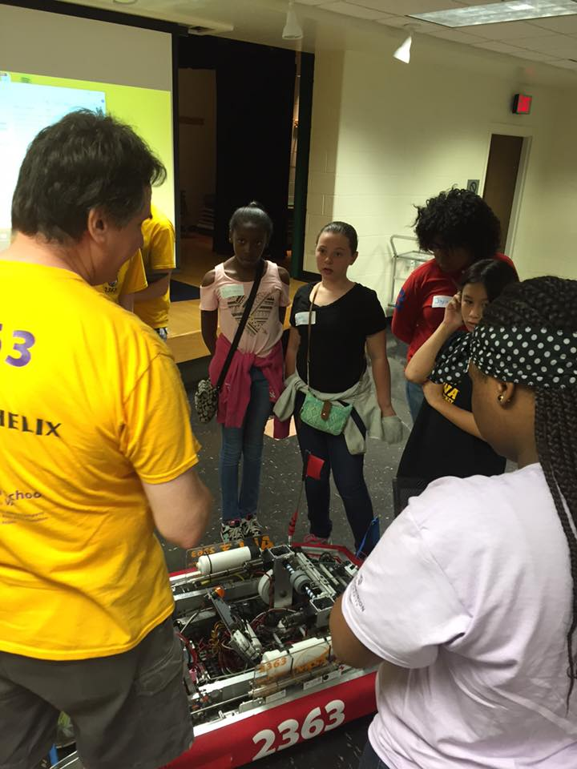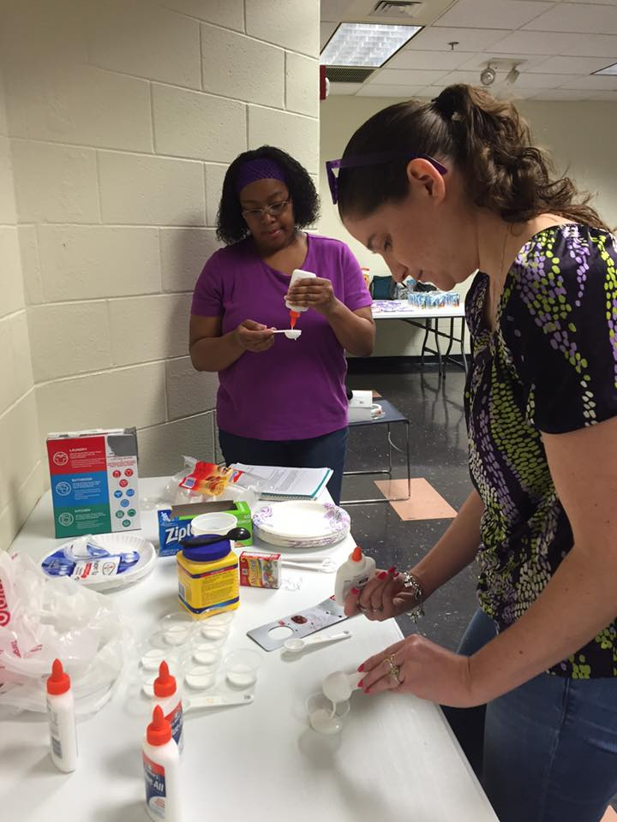
Appendix E
Press Release
Appendix F
Flyer

