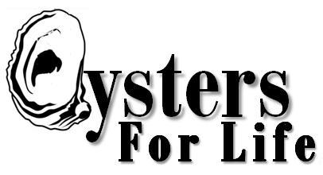
“Virginia Jaycees/Oysters for Life”
INDIVIDUAL/CHAPTER/REGION “ACT TO IMPACT”
RECOGNITION AWARD LEVELS
(EACH OYSTER CAGE PACKAGE IS BASED ON $175.00/ CERTIFICATES & PRIZES AWARDED!)
INDIVIDUAL CATEGORY CORPORATE/GROUP Membership Recognition Levels
“ONE EYED LARVAE” ENTRY LEVEL “LARVAE STREAM” $175.00 (1 CAGE) - $525.00 (3 CAGES)
“SPAT” STRIKE LEVEL “SPAT ON SHELL” $700.00 (4 CAGES) - $1750.00 (10 CAGES)
“SEED OYSTER” NUTURING LEVEL “CULTCH CLUSTER” $1,925.00 (11 CAGES) - $4,200.00 (24 CAGES)
“DEEP CUP OYSTER” MATURED LEVEL “OYSTER ROCKEFELLER” $4,375.00 (25 CAGES) - $8,575.00 (49 CAGES)
“PEARL” HARVEST LEVEL “PEARL” $8,750.00 (50 CAGES) AND UP……
CHAPTER LEVELS (multiply x 10 cages)
REGION LEVELS (multiply x 100 cages)

